Environment Setup

Resources needed with version:

* TestComplete 10.30
* Firefox 32.0.1
* Chrome 39.0.2
* IE 11.0.9
* Add a patch file for both **Firefox** and **Chrome**. Here are the links...

http://support.smartbear.com/downloads/testcomplete/firefox-patches/

http://support.smartbear.com/downloads/testcomplete/chrome-patches/

* Enable the **TestComplete extension** in **Chrome**.  
  chrome://extensions/
* For setting up the browsers for web testing go through the below links...

http://support.smartbear.com/viewarticle/56974/

* Add the required parameters in EmailSender project to send the mail.

Example:

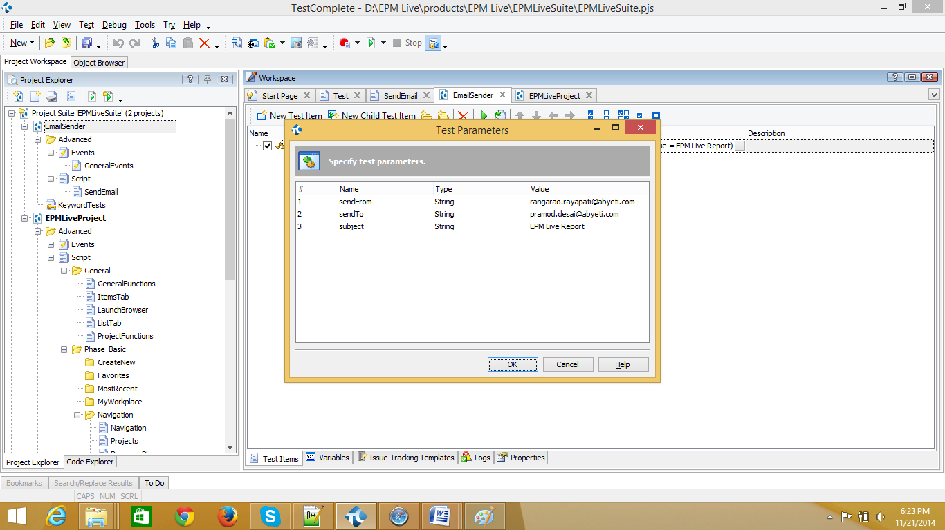

* Change the project path in the .bat file. You can find batch file EPM_Live_Test_Executor at  
  ..Project\EPM Live\products